1. Create a simple line plot using matplotlib with the following data:
   1. X = [1,2,3,4,5]
   2. Y = [9,11,7,22,40]
2. Create a scatter plot to visualize the data below:
   1. X = [5, 7, 8, 7, 2, 17, 2, 9, 4, 11, 12, 9, 6]
   2. Y = [7, 8, 2, 4, 7, 11, 15, 7, 10, 8, 4, 2, 7]
3. Create a bar char to visualize the data below:
   1. X = [‘Apple’, ’Oranges’, ’Watermelon’, ‘Pear’]
   2. Y = [10,22,1,5]
4. Load the [Bank and Credit Card Complaints](https://www.kaggle.com/datasets/mexwell/bank-and-credit-card-complaints) dataset and create a data visualization with Matplotlib based on your findings in the dataset. Any type of chart or graph is acceptable. Include relevant labels, titles, and annotations to make the visualization clear and informative.
5. Choose or generate a dataset of your own and generate visualizations with Matplotlib. Any type of chart or graph is acceptable. Include relevant labels, titles, and annotations to make the visualization clear and informative.

# Answer

Q1. Line Plot using 2 sets of data represent X and Y.

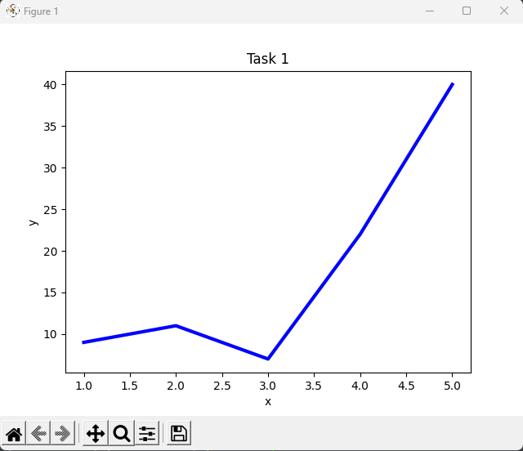

Q2. Scatter Plot using 2 sets of data represent X and Y with preset size of 10.

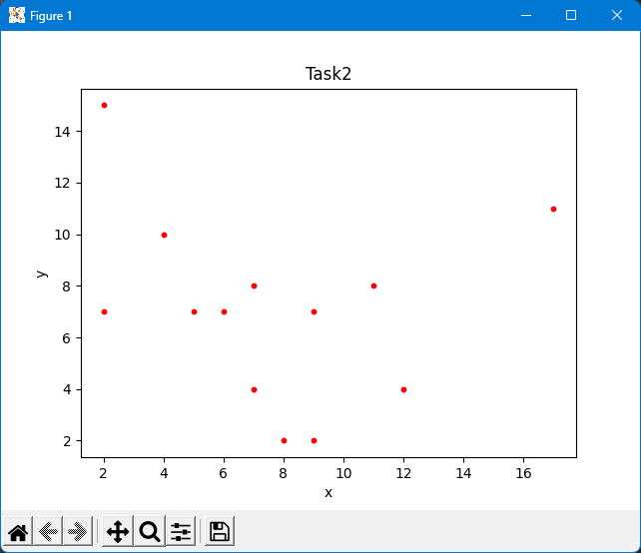

Q3. Bar Chart using 2 sets of data represent X as Fruits and Y as Count.

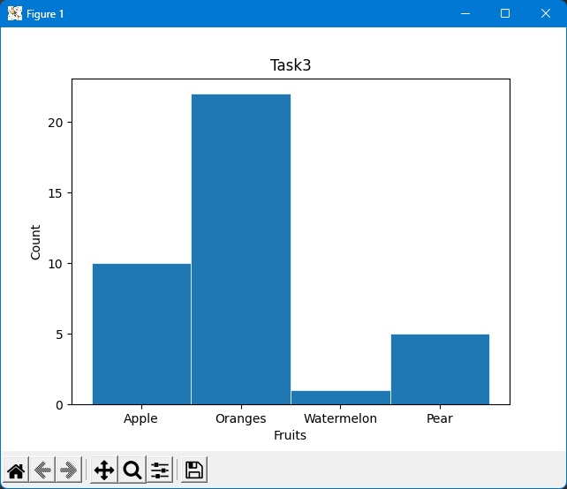

Q4. Using credit_card_complaints.csv file as data source, below are the 4 Charts been generated based on various fields including Issues, Count, State, Submission, Response.

1. Bar Chart represents Type of Issues VS Count, with automated High Low value indicator and X value labeling. In below Chart, there are total of 33 types of issues has been recorded. The highest count of 14827 is recorded under Billing Disputes and lowest count of 145 is recorded in Convenience Checks. The data range in below chart is 14682, which represent the spread of the data.

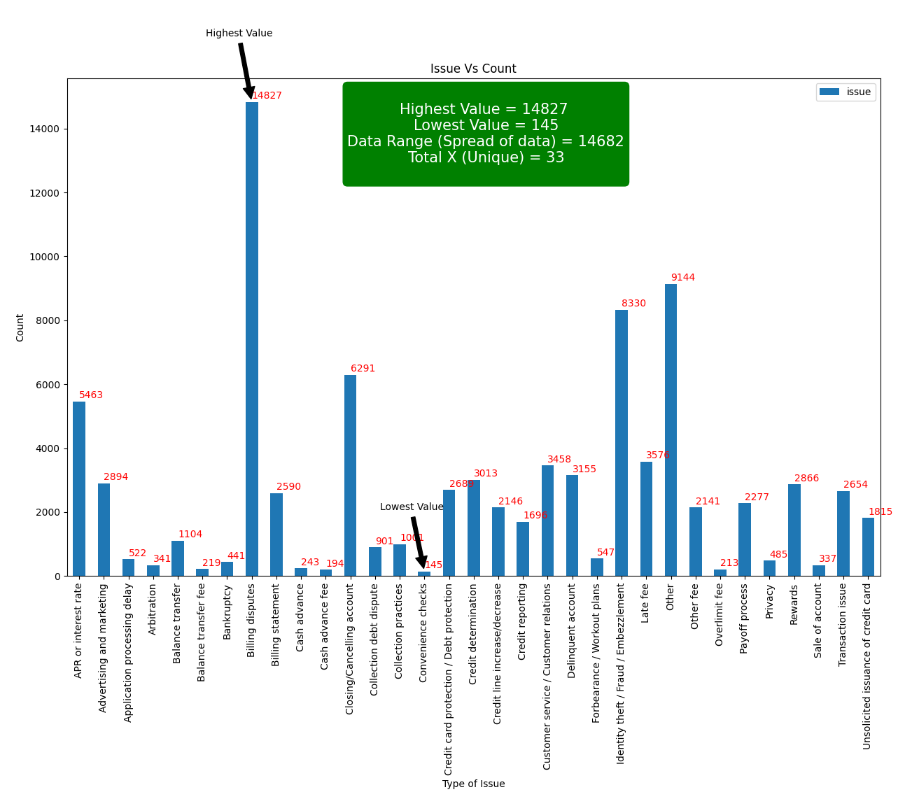

1. Bar Chart represents State VS Issues, with automated High Low value indicator and X value labeling. In below Chart, there are total of 62 States has been recorded. The highest count of 12102 is recorded under CA State and lowest count of 2 is recorded in AA State. The data range in below chart is 12100, which represent the spread of the data.

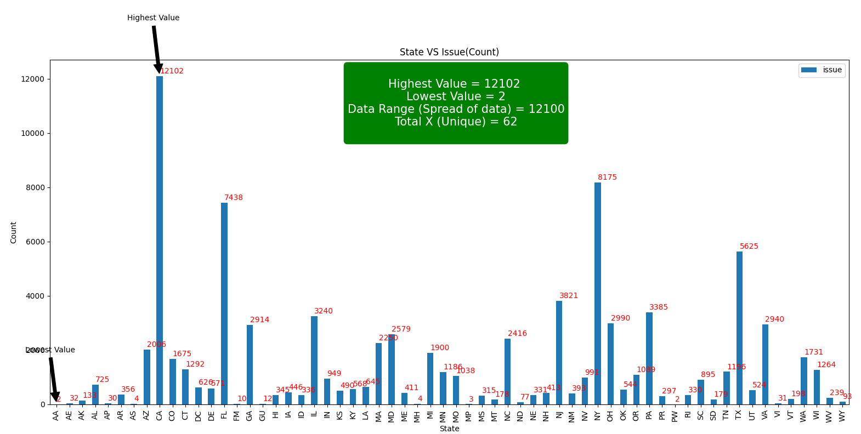

1. Bar Chart represents Submission VS Issues, with automated High Low value indicator and X value labeling. In below Chart, there are total of 6 Submission types has been recorded. The highest count of 60384 is recorded in Web and lowest count of 43 is recorded in Email. The data range in below chart is 60341, which represent the spread of the data.

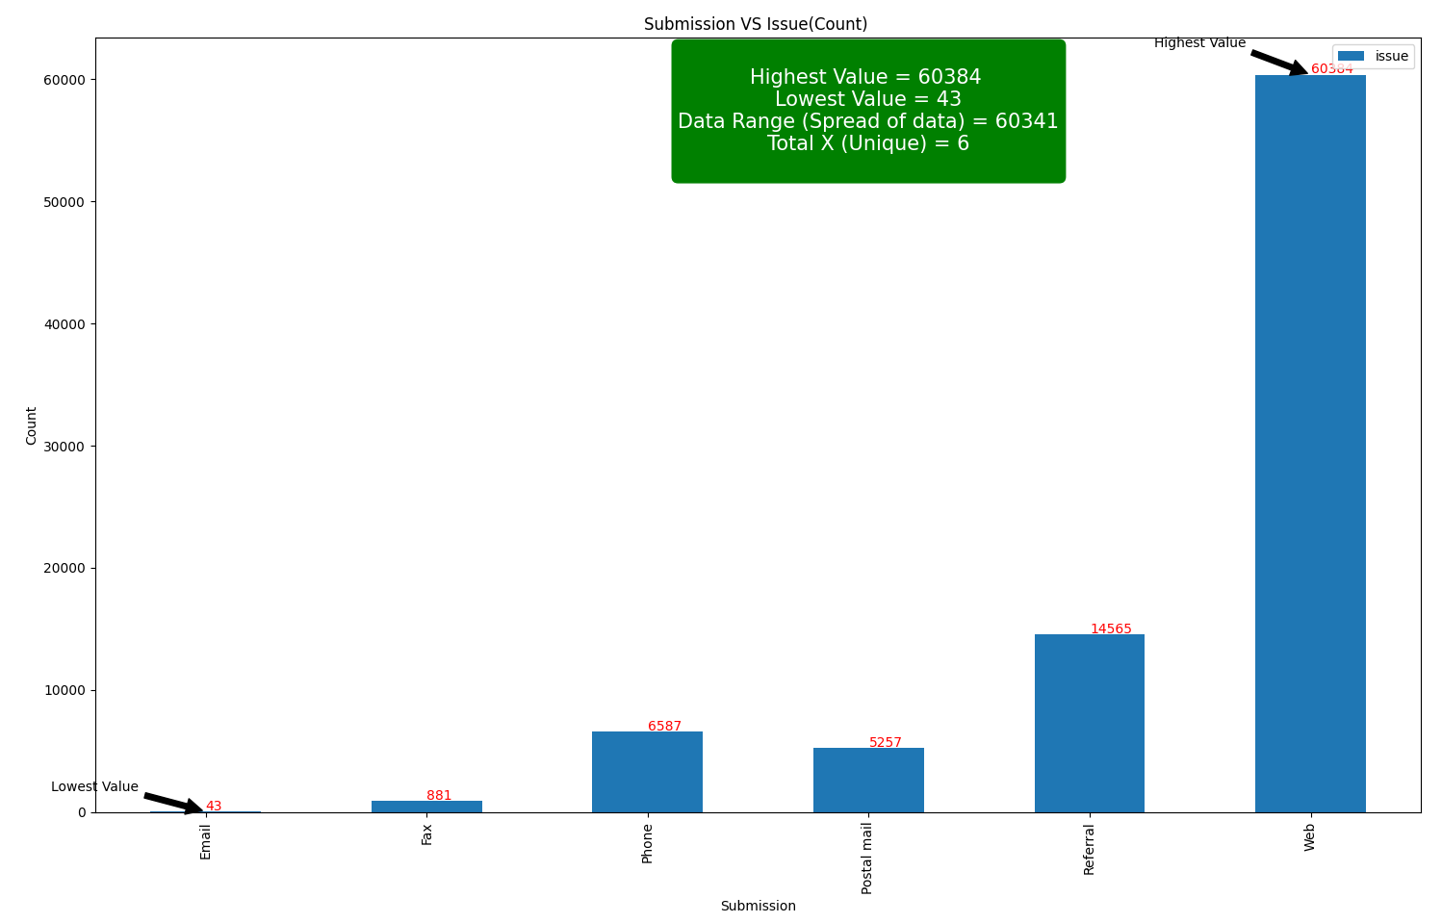

1. Bar Chart represents Company Response VS Issues, with automated High Low value indicator and X value labeling. In below Chart, there are total of 8 Category of Company Responses has been recorded. The highest count of 52384 is recorded in “Closed with explanation” and lowest count of 141 is recorded in “Untimely response”. The data range in below chart is 52243, which represent the spread of the data.

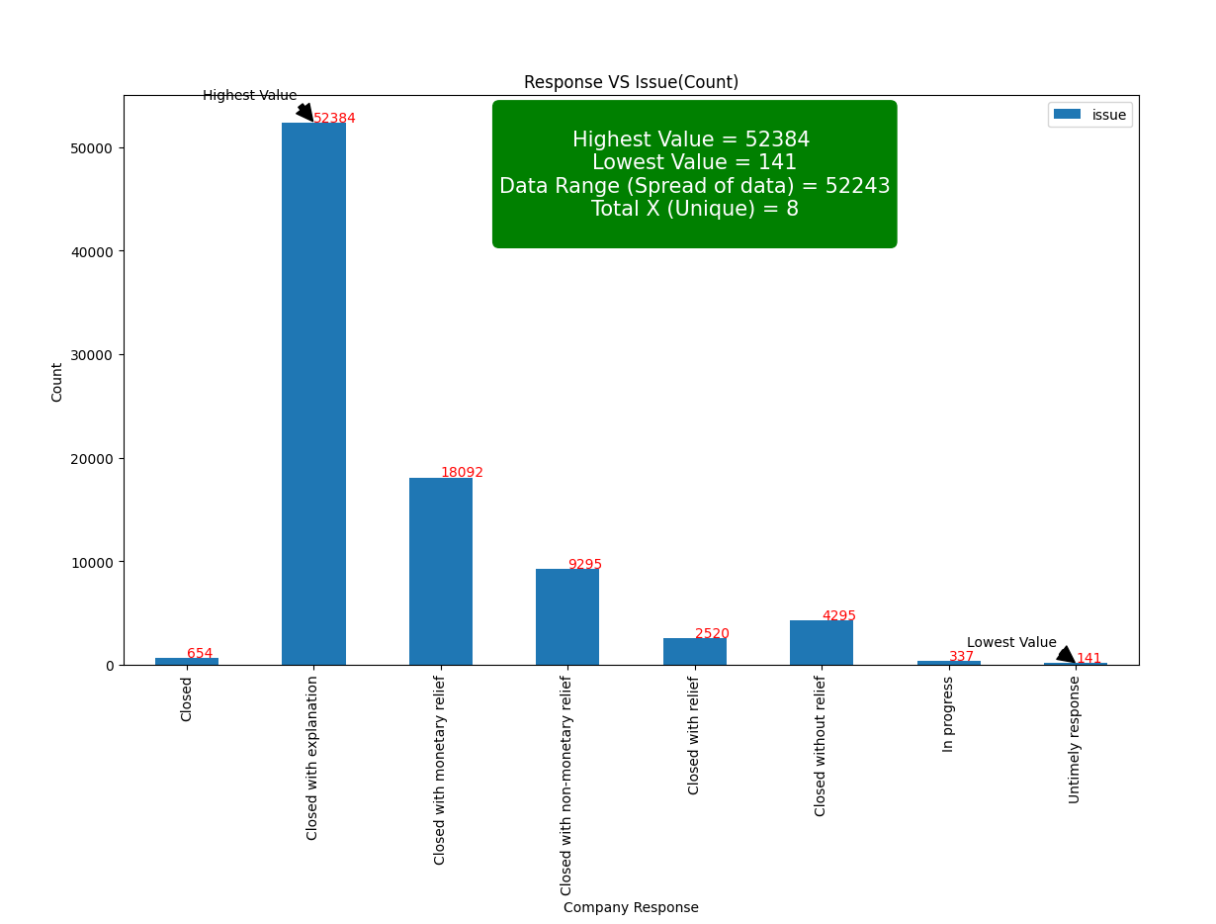

Q5. Using ganesh_ds.csv file as data source, Scatter Plot is generated with automated High Low value indicator. The below Scatter Plot represents Persons Name and their Blood Pleasure, with automated High Low value indicator. Their body weight determines the Plot Size area.

There are total of 9 Persons data has been recorded. The highest blood pressure value of 160 is recorded under Priya and lowest blood pressure of 90 is recorded under John. The data range in below chart is 70, which represent the spread of the data.

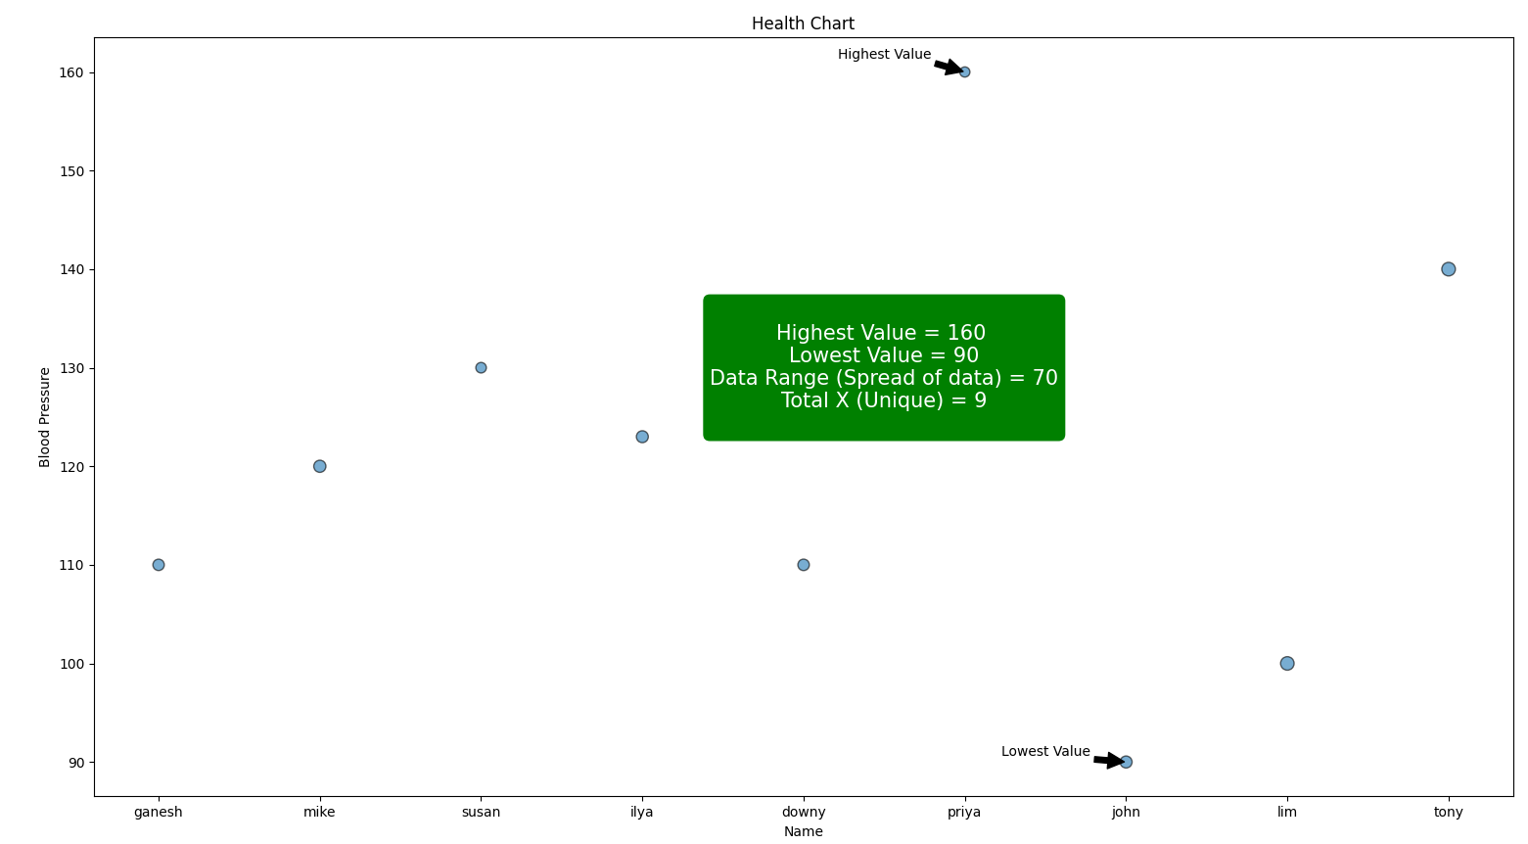

Py_Scripts Folder Contains below

|  |  |  |
| --- | --- | --- |
| No | Script Name | Usage |
| 1 | Q1.py | Generate answer for Q1 |
| 2 | Q2.py | Generate answer for Q2 |
| 3 | Q3.py | Generate answer for Q3 |
| 4 | Q4-A.py  Q4-B.py  Q4-C.py  Q4-D.py | Generate answer for Q4 |
| 5 | Q5-A.py | Generate answer for Q5 |